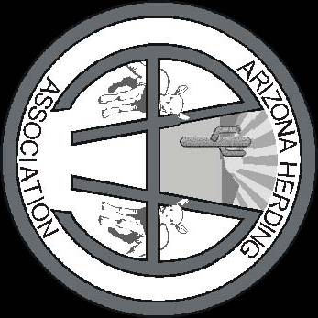
Ken Ferrill
HC 66 Box 140
Mountainair NM 87036

FIRST CLASS
DATED MATERIAL

ENTRIES CLOSE:
Monday, September 30th @ 11:00 PM MST

Premium List
EVENT #s: 2019515607, 2019515608, 2019515609, 2019515610, 2019515611, 2019515612
ARIZONA Fall-CHUTE OUT
(Licensed by the American Kennel Club)
Hosted by the Arizona Herding Association
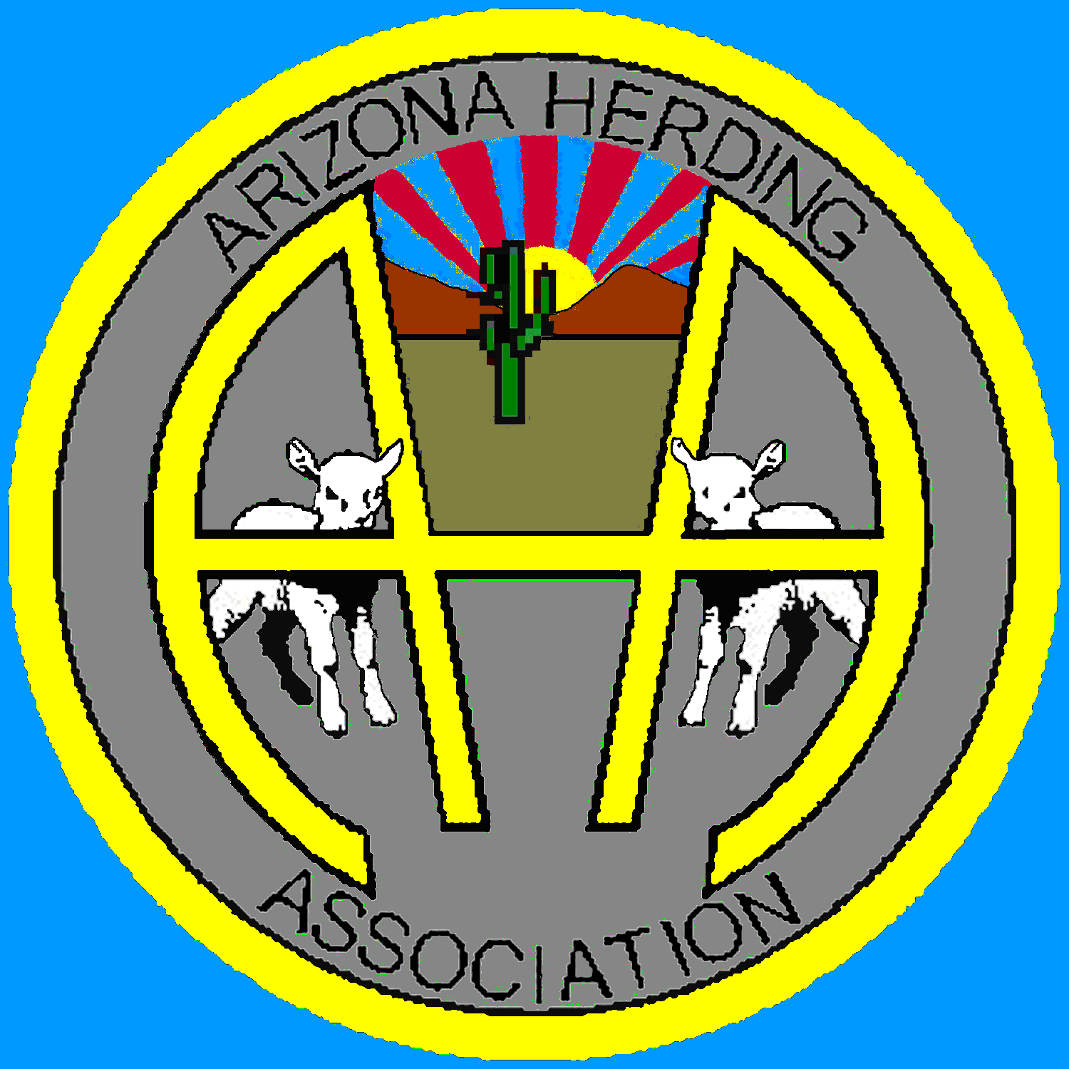
SATURDAY, OCTOBER 12, 2019
SUNDAY, OCTOBER 13, 2019

ENTRIES OPEN Monday Sept 2nd, 2019 8:00 AM MST
ENTRIES CLOSE: Monday Sept 30th, 2019 11:00 PM MST at Secretary’s office after which time entries cannot be accepted, canceled or substituted.
METHOD OF ENTRY: First received. See NOTICE TO EXHIBITORS.
When entry limit is reached, additional entries will be placed on an alternate’s list.
DRAWING FOR RUNNING ORDER: Tuesday October 1st, 2019, 6 PM at Secretary’s office.
ENTRY LIMIT: Total of 50 runs per day per judge, or depending upon availability of stock This event will be held outdoors regardless of weather at
Double M Stockdogs
TRIAL CLASSES OFFERED
Course A - All Levels: Sheep, Ducks/Geese
……………………………………………………..
TEST CLASSES OFFERED
Pre-Trial Test - Sheep or Goats …. Herding Tested – Sheep or Goats
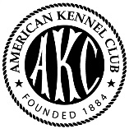 | Certification Permission has been granted by the American Kennel Club for the holding of these events under The American Kennel Club Rules and Regulations. Gina M. Dinardo, Secretary
NOTICE TO EXHIBITORS
Trial hours: 6:30 AM to 9:00 PM. Grounds will be available Friday through Monday.
Method of Entry Entries will be prioritized by a random drawing for each day of receipt. Entries must have clearly visible USPS postmark, email dated 3 days after opening date, or online entry dated 3 days after opening date. No metered mail allowed. No FEDEX, DHL, UPS, telephone, or faxed entries. Express or overnight entries will be accepted only if signature waived, to 839 Solomon Rd Mountainair NM 87036
Closing Date In accordance with Chapter 6, Section 9 of AKC Dog Show Rules, entries will close on said date or when the limit has been reached, if prior thereto. Entries must be received at the Trial Secretary’s address by the published closing date to be acceptable. Incomplete, unsigned, conditionals, telephone, telegraph, or entries received without fees are not acceptable. Entries must be on the enclosed blank or a reasonable facsimile thereof. Each entry must have the waiver/agreement attached.
Eligibility Open to all AKC Recognized Herding Breeds and Foundation Stock Service Breeds on the AKC website: http://www.akc.org/events/herding/eligible_breeds.cfm
Dogs with PAL/ILP Numbers, nine months of age or older, may enter Tests and Trials.
Bitches in season shall be eligible and will run at the end of their class in tests and in catalog order in trial classes. Please notify the Event Secretary if your bitch is in season.
Returned checks do not constitute a valid entry fee. The Trial Secretary will assess a collection fee of $50.00 in addition to the amount of each returned check. Subsequent entries from the same exhibitor may result in their being put on a cash-only basis.
Entry fees shall not be refunded in the event that a dog is absent (unless replaced by an alternate), disqualified, excused by a veterinarian, judge or tester or barred from competition by the Show Committee. Any dogs aggressive to persons or stock will be removed. (See Chapter 1, Section 22 of the American Kennel Club Herding Rulebook.) No refund for duplicate entries. Every effort will be made to find all duplicate entries, but if an entry has been processed, no refund will be made. If, because of riots, civil disturbance, or other acts beyond control of the Club, it is impossible to open or complete the show, no refund of entry will be made.

Dogs must be ready for their classes. Test/Trial judges have the authority to refuse to judge any dog that does not appear within five minutes of being called for its run. The Test/Trial-giving Club and the Test/Trial Secretary have no obligation or responsibility for providing service through a public address system or stewards or runners for the purpose of calling or locating dogs that are not brought into the ring when required.
The club may decline any entries for cause and may refuse to receive or may remove any dog on account of disease, viciousness, or other causes, and no one shall have any claim or recourse against the club or any official thereof.
Single copies of the latest editions of the “Rules Applying to Dog Shows”, the “Obedience Regulations” and the “Regulations for Herding Tests and Trials” may be obtained from the AMERICAN KENNEL CLUB, 51 MADISON AVENUE, NEW YORK, NEW YORK 909.

EXHIBITORS PLEASE NOTE
The Arizona Herding Association does not agree to arbitrate clams as set forth on the official AKC entry form for this event.

2019 OFFICERS –
ARIZONA HERDING ASSOCIATION
President  Vice President  Treasurer  Secretary  Stock Chair | Molly Wisecarver, 19420 Kennedy Dr., Mayer, AZ 86333  Mary-Alice Wisecarver, 19420 Kennedy Dr., Mayer, AZ 86333  Steve Wisecarver, 19420 Kennedy Dr., Mayer, AZ 86333  Robin Knight, PO Box 360, Gilbert, AZ 85289-0360  Kenneth Ferrill HC 66 Box 140 Mountainair NM 87036 | 928-499-9263  928-499-9263  928-499-92863  480-546.35-0601  602-390-5825

ARIZONA HERDING ASSOCIATION TRIAL/TEST COMMITTEE
Trial Chairperson | Molly Wisecarver, 19420 Kennedy Dr., Mayer, AZ 86333 | 928-499-9263
Trial Secretary | Ken Ferrill, HC 66 Box 140 Mountainair NM 87036  kenferrillakcsec@earthlink.net | 602-390-5825
Course Dir & Grnds  Chief Stock Handler | Sue Bradely 526 N Ash Pl Benson, AZ, 85602  Steve Wisecarver 19420 Kennedy Dr., Mayer, AZ 86333 | 520-400-0828  928-499-9263
Awards | Kim Gauchat 15208 S 140 St Gilbert AZ 85285 | 602-703-5794

VETERINARIAN ON CALL
Veterinarian (on call)
Kachina Animal Hospital
E State Route 69,Dewey, AZ 86328
928-772-8225

COURSES

Course A: Sheep, Ducks,

Started, Intermediate, Advanced

LIVESTOCK
SHEEP | Crossbred sheep | 3-5 head per run | Replacement cost: $350/head
Geese | Crossbred Geese | 5 head per run | Replacement cost: $40/head
GOATS | Mixed breed | 3-5 head per run | Replacement cost: $200/head

ENTRY INFORMATION

ENTRY FEES:
(Includes $3.50 AKC Fees)
$46.35 per Sheep A run
$46.35 per Duck A run

$46.35 per HT or PT Test run (Sheep or Goats)
Same fees/stock for Tests and Exhibition Only
Make checks payable to:
Arizona Herding Association (AHA)
MAIL ENTRIES AND MAKE DIRECT INQUIRIES TO:
Ken Ferrill
HC 66 Box 140
Mountainair NM 87036
kenferrillakcsec@earthlink.net
Do not send entries by any method requiring signature for delivery
Entry Confirmations and Judging Programs will be sent via e-mail, if available.

AKC JUDGES

Judge CAROL D DONNELLY

Judge JOY HALL

JUDGING ASSIGNMENTS

Saturday, Oct. 12th, 2019, Event #2019515607
Course A Sheep: Started, Intermediate, Advanced Judge CAROL D DONNELLY
Herding Test (sheep/goats) JUDGE CAROL D DONNELLY
Pre-Trial Test (sheep/goats) JUDGE CAROL D DONNELLY

Saturday, Oct. 12th, 2019, Event #2019515608
Course A Geese/Ducks: Started, Intermediate, Advanced JUDGE JOY HALL

Saturday, Oct. 12th, 2019, Event #2019515609
Course A Sheep: Started, Intermediate, Advanced JUDGE JOY HALL

Sunday, Oct. 13th, 2019, Event #2019515610
Course A Sheep: Started, Intermediate, Advanced JUDGE JOY HALL
Herding Test (sheep/goats) JUDGE JOY HALL
Pre-Trial Test (sheep/goats) JUDGE JOY HALL

Sunday, Oct. 13th, 2019, Event #2019515611
Course A Geese/Ducks: Started, Intermediate, Advanced JUDGE CAROL D DONNELLY

Sunday, Oct. 13th, 2019, Event #2019515612
Course A Sheep: Started, Intermediate, Advanced JUDGE CAROL D DONNELLY

LOCAL ACCOMMODATIONS

WHICH ACCEPT DOGS
The following motels will accept well behaved pets; please clean up after your dogs on the motel grounds so we will be welcomed back again. Motels are about 20 miles from the trial site. [Be sure to check current pet policies, they change without notice.]
CORDES JUNCTION MOTEL AND RV PARK
(Some dog rooms, $9.00 surcharge)
19780 Hitching Post Way, Cordes Junction, AZ 86333
Junction of I17 & Highway 69
928-632-5186
www.motelrvpark.com
TESKEY'S
(Some dog rooms, $9.00 surcharge)
9050 South Highway 69, Mayer, AZ 86333
928-632-9696
CREEKSIDE PRESERVE
(Dog friendly, $9.00 surcharge)
9255 South Highway 69, Mayer, AZ 86333
928-632-0777

TRIAL SITE DIRECTIONS
Directions from Phoenix
From Flagstaff: Take I-17 South, exit 263 Arcosanti, make a RT on Arcosanti road to the round about. Turn onto Hwy 69 (1/4 turn on the round about) make your first RT, no Street sign, the turn is right in front of the HWY sign that reads Mayer 8 miles, Turn RT on the frontage road, LT at the mail boxes (dirt road) take down about a ½ mile we are on the LT side with double green gates, gate open automatically.

Directions from Flagstaff
Take I-17 South, exit 263 Arcosanti, and make a RT on Arcosanti road to the roundabout. Turn onto Hwy 69 (1/4 turn on
the roundabout) make your first RT, no Street sign, the turn is right in front of the HWY sign that reads Mayer 8 miles,
Turn RT on the frontage road, LT at the mail boxes (dirt road) take down about a ½ mile we are on the LT side with
double green gates, gate open automatically.
EMERGENCY & DISASTER PROCEDURES

FIRE/ POLICE/ AMBULANCE / MEDICAL EMERGENCIES – DIAL 911

.All dogs should be crated or leashed securely and owners/handlers must make sure that they, their dogs, and vehicles are out of any driveway.

THUNDERSTORMS WITH LIGHTNING: All people and dogs should be in the security of their vehicles until the storm has passed. Testing and trialing will be delayed.
INJURY TO A DOG Alert the veterinarian on-call (928-772-8225) and the owner/handle and the dog should proceed to the Kachina Animal Hospital,
12226 E Turquoise Circle, Dewey, Arizona 86328.

Directions to the veterinary clinic from Double M Stockdogs:
- • Go west on East Kennedy Drive, turn right onto AZ-69.
- • Proceed west on AZ-69 (about 17.5miles) to AZ-69N.
- • Turn Right onto AZ69-N
- • • Continue 194 ft to 850 South Henrickson, the Kachina Animal Hospital

INJURY OR HEALTH PROBLEM WITH A PERSON:
The emergency response team for the area will be called immediately. Dial 910.
A First Aid kit is at the Secretary’s table.
Nearest hospital: Yavapai Regional Medical Center East, 7700 E Florentine Rd,
Prescott Valley, AZ 86314 (928-446.35-2800)

Exhibitors must be governed by any rules or regulations of civil authority, building and parking restrictions. Vehicles parked contrary to regulation will be subject to towing at the owner's expense.

RIBBONS/ROSETTES AND AWARDS

All ribbons and awards must be picked up the day they are won; none will be held over or mailed.

Sponsored by AZ Herding Association

TRIALS

First Place--Blue ribbon

Second Place--Red ribbon

Third Place--Yellow ribbon

Fourth Place--White ribbon

Fifth Place--Pink ribbon

Qualifying Score--Dark Green ribbon

High-in-Trial--Blue, Red, and Yellow Rosette

Reserve High-in-Trial--Red, Yellow and White Rosette

TESTS

Qualifying Score--Dark Green ribbon

AWARDS for Trials and Tests

High-in-Trial Sheep—Dog/Herding Related Item

High-in-Trial Ducks—Dog/Herding Related Item

High-Scoring Junior—Dog/Herding Related Item

EXHIBITORS:

BRING SHADE, SUNSCREEN, AND DRINKING WATER

FOOD: see following page for pre-ordering of home cooked meals.
Nearest food, other than pre-ordered, is about thirty minutes away.
KEEP THE TRIAL SITE CLEAN. We ask your cooperation so that we may retain the use of this facility for future Tests/Trials. This is a self-cleaning show. Please pick up after your dogs.

***PLEASE SUBMIT THIS PAGE, ALONG WITH YOUR ENTRY FORMS, FOR ANY OF THE FOLLOWING ITEMS:
CATALOGS
Catalogs will be available for $5.15 each. Pre-order and pre-payment only! (Note: Per AKC rules, a random drawing will be done for each day’s runs which will be reflected in the catalog.) .
I would like to order ____ catalogs. Payment is enclosed. **
**Amount enclosed (payable to AHA/may be added to entry fees): $________________

LUNCHES

Pre-order and pre-payment only. $5.00 per lunch**
Saturday | Sunday | Monday
LUNCH #____ | LUNCH #____ | LUNCH #____

**Amount enclosed (payable to AHA/may be added to entry fees): $________________

CAMPING

RV Parking is permitted on the trial grounds. are no hook-ups. Please submit the following form to Molly Wisecarver if you plan to stay overnight. Well-mannered dogs only. No LOOSE dogs. Owners must assume full responsibility. Any questions, contact Molly 928-499-9263. Submit the following form with check payable to Molly Wisecarver for camping. Mail to: Ken Ferrill, HC 66 Box 140 Mountainair, NM 87036

RV PARKING/CAMPING
Friday | Saturday | Sunday | Monday

ALL AMERICAN KENNEL CLUB RULES REGARDING CONDUCT WILL BE STRICTLY ENFORCED

This page submitted by: (name) ________________________________

(E-mail) _______________________________________________

Arizona Herding Association
A.K.C. LICENSED HERDING TESTS & TRIALS
Trial site: Double M Stockdogs 19420 Kennedy Mayer AZ86333
EVENT #s: Saturday, Oct. 12th, 2019: 2019515607, 2019515608; 2019515609
Sunday, Oct. 13th 2019: 2019515610, 2019515611: 2019515612
Entry fees: Course A sheep/HT/PT: $46.35 per dog; Course A ducks: $46.35 per dog;
Same fees apply for FEO only.

After closing date (09/30/2019, 11:00pm) entries cannot be accepted, canceled, or substituted, except as provided for in
Chapter 3 Section I of the Regulations for Herding Tests and Trials.
Event Limit: 50 runs per day per judge or depending upon availability of stock.

Send to: Ken Ferrill, Trial Secretary

HC 66 Box 140 Mountainair NM 87036
Include waiver/agreement with each entry form. One form per dog.

Do not send entries by any method which requires signature for delivery. Please Print Legibly

Entry fees payable to AHA (US funds) enclosed ______________. FOR EXHIBITION ONLY (FEO) Read carefully and ENCLOSE the agreement on the <Opposite> Side before mailing.
SATURDAY |  | SUNDAY
Course A Sheep Event 2019515607  Started Inter. Adv. |  | Course A Sheep Event 2019515610  Started Inter. Adv.
Course A Ducks Event 2019515608  Started Inter. Adv. |  | Course A Ducks2019515611  Started Inter. Adv.
Course A Sheep Event 2019515609  Started Inter. Adv. |  | Course A Sheep Event 2019515612  Started Inter. Adv.
Tests/Sheep/Goats  HT PT |  | Tests/Sheep/Goats  HT PT

Breed: |  | Variety | Sex: |  | Date of Birth:
REGISTERED NAME OF DOG (AKC titles only):

Registration No: |  |  |  | Call Name:
____ AKC # ____ PAL/ILP # ____ FSS# ____ Foreign Reg. #. & Country
Breeder:

Sire:

Dam:

Actual Owner(s) : PLEASE PRINT

Address:

Name of owner’s agent (if any):

I CERTIFY that I am the actual owner of the dog, or that I am the duly authorized agent of the actual owner whose name I have entered above. In consideration of the acceptance of this entry I (we) agree to abide by the rules and regulations of the American Kennel Club in effect at the time of this Herding Test or Trial and by any additional rules and regulations appearing in the premium list for this Herding Test or Trial or both, and further agree to be bound by the "Agreement" printed on the reverse side of this entry form. I (we) certify and represent
that the dog entered is not a hazard to persons or other dogs. This entry is submitted for acceptance on the foregoing representation and agreement. I (we) agree to conduct myself(ourselves) in accordance with all such Rules and Regulations (including all provisions applying to discipline) and to abide by any decisions made in accord with them.
SIGNATURE of owner or agent duly authorized to make this entry:
PHONE: | E-MAIL:

WAIVER, RELEASE AND INDEMNITY AGREEMENT
REPRESENTATIONS I make the following representations: (1) that my dog(s) and I are in good health; (2) that my dog(s) are friendly and not a hazard to people, other dogs, stock, or any other property; (3) that I have been given the opportunity to inspect the subject premises prior to undertaking these herding activities and that I have either inspected the premises for any hazards and defects or I do hereby waive my right to inspect them; and, (4) that I will obey any rules imposed as a condition of working livestock on the premises where the stockdog activity is taking place. Further, I represent that I am the owner of the dog(s) being trialed or that I have been engaged by the owner to participate in this herding trial on the owner’s behalf and that I am authorized to execute this Waiver, Release and Indemnity on behalf of myself and the owner. If I am not the owner of the dog being worked the name, address and telephone number of the owner is written below or on the other side of this document. For ease of reference, the words “my dog(s),” as used herein, are intended to include all dogs that I am working, whether or not owned by me.
ELIGIBILITY
All dogs nine (9) months of age or older that are registered with the American Kennel Club and have been accepted into the herding program are eligible to participate in herding tests and trials. Eligible dogs include those classified as Herding Dogs under Chapter 3 of the Dog Show Rules, and dogs enrolled in the Indefinite Listing Privilege (ILP) or Purebred Alternative Listing (PAL) program. Dogs enrolled in the AKC Foundation Stock Services (FSS) program are eligible but may earn suffix titles only. No dog may be entered in two classes on the same course with the same kind of stock under the same judge at any test/trial. Bitches in season shall be eligible and will run at the end of the class in tests, and in catalog order as listed in the class in trials. Refer to the Herding regulations Chapt 1 Sec 3 for further information. A dog must be entered in the name of the person who actually owned it at the time entries for the herding test or trial closed. If a registered dog has been acquired by a new owner, it must be entered in the name of its new owner in any herding test or trial for which entries closed after the date of acquisition, regardless of whether the new owner has received the registration certificate indicating that the dog is recorded in his or her name. State on entry form whether transfer application has been mailed to AKC. (for complete rule refer to Chap. 9, Sect 3 of “Rules Applying to Dog Shows”)AKC Rules, Regulations, Policies and Guidelines are available on the American Kennel Club Web site, www.akc.org
AGREEMENT
I (we) agree that the club holding this event has the right to refuse this entry for cause which the club shall deem sufficient. In consideration of the acceptance of this entry and of the holding of this event and of the opportunity to have the dog judged and to win prizes, ribbons, or trophies, I (we) agree to hold the AKC, the event-giving club, their members, directors, governors, officers, agents, superintendents or event secretary and the owner and/or lessor of the premises and any provider of services that are necessary to hold this event and any employees or volunteers of the aforementioned parties, and any AKC approved judge, judging at this event, harmless from any claim for loss or injury which may be alleged to have been caused directly or indirectly to any person or thing by the act of this dog while in or about the Herding Test or Trial premises or grounds or near any entrance thereto, and I (we) personally assume all responsibility and liability for any such claim; and I (we) further agree to hold the aforementioned parties harmless from any claim for loss, injury or damage to this dog. Additionally, I (we) hereby assume the sole responsibility for and agree to indemnify, defend and save the aforementioned parties harmless from any and all loss and expense (including legal fees) by reason of the liability imposed by law upon any of the aforementioned parties for damage because of bodily injuries, including death at any time resulting therefrom, sustained by any person or persons, including myself (ourselves), or on account of damage to property, arising out of or in consequence of my (our) participation in this event, however such, injuries, death or property damage may be caused, and whether or not the same may have been caused or may be alleged to have been caused by the negligence of the aforementioned parties or any of their employees, agents, or any other persons. I (WE) AGREE THAT ANY CAUSE OF ACTION, CONTROVERSY OR CLAIM ARISING OUT OF OR RELATED TO THE ENTRY, EXHIBITION OR ATTENDANCE AT THE EVENT BETWEEN THE AKC AND THE EVENT-GIVING CLUB (UNLESS OTHERWISE STATED IN ITS PREMIUM LIST) AND MYSELF (OURSELVES) OR AS TO THE CONSTRUCTION, INTERPRETATION AND EFFECT OF THIS AGREEMENT SHALL BE SETTLED BY ARBITRATION PURSUANT TO THE APPLICABLE RULES OF THE AMERICAN ARBITRATION ASSOCIATION. HOWEVER, PRIOR TO ARBITRATION ALL APPLICABLE AKC BYLAWS, RULES, REGULATIONS AND PROCEDURES MUST FIRST BE FOLLOWED AS SET FORTH IN THE AKC CHARTER AND BYLAWS, RULES, REGULATIONS, PUBLISHED POLICIES AND GUIDELINES.

